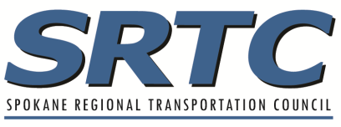
STBG Capital Maintenance Supplement
2024-2026 SRTC Call for Projects

PROJECT TITLE:

capital maintenance – 100 points

☐Preservation ☐ Reconstruction

Pavement Condition
What is the structural condition of the existing facility? Please provide the Overall Condition Index (OCI) rating. Note: OCI will be reviewed by a team of representatives from Spokane, Spokane Valley, Spokane County, and WSDOT prior to project scoring.

OCI

Year

Preservation
☐OCI: 41-55 65
☐OCI: 56-65 35
☐OCI: 66-85 100

Reconstruction
☐OCI: 0-30 100
☐OCI: 31-40 65
☐OCI: 41-55 35

Please explain.

