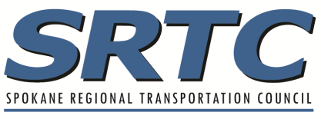
2024-2026 SRTC Call for Projects

Local Agency Project Endorsement

PROJECT TITLE:
The attached project application reflects established local funding priorities consistent with the adopted local plans and/or programs.
The project described is financially feasible; local match revenue identified on the project application is available and will be committed to the project if it receives the requested grant.
Costs identified in the application represent accurate planning level estimates needed to accomplish the work described herein. As stated in policy 6.1 of the 2022 TIP Guidebook, any cost overruns are the responsibility of the project sponsor.
The project sponsor must certify that they will utilize all project delivery tools available, including eminent domain, to acquire ROW, if necessary, to meet project obligation schedules.
The use of federal funds for this project entails administrative and project compliance for which the project sponsor will be responsible.
This project has the full endorsement of the governing body/leadership of this agency or organization. This document must be signed by a person in a position or a representative of a governing body that has the authority to make decisions for the entire organization. It is up to the applicant to determine the appropriate representative to sign this endorsement.

Name and Title of Designated Representative

______________________________________
Signature of Designated Representative Date

