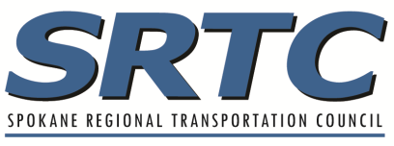
Eligibility Worksheet
2024-2026 SRTC Call for Projects

PROJECT TITLE:

General Project Information

Agency or Organization Phone Number

Contact Person Email Address

Project Location

☐ Urbanized Area ☐Urban Small ☐Rural

Project Description
Project scope (include termini and length)

Existing and proposed conditions

Project purpose and outcomes

CA Sponsor

If your agency does not have Certification Acceptance (CA) Status, please provide the CA Sponsoring Agency Endorsement:

Agency Approving Authority Name:

Title:

Date:

ROW/Property Rights

Does your project anticipate property rights outside of your ownership on other agency or private land owner property?
☐Yes ☐No

If yes, please describe anticipated needs and coordination with affected agencies, etc.

Project Delivery Tools
☐ The project sponsor must certify that they will utilize all project delivery tools available, including eminent domain, to acquire ROW, if necessary, to meet project obligation schedules.

Attachments
☐Vicinity map ☐ Cross-Sections ☐ GIS Shapefile (if readily available) ☐ Safe & Complete Streets Checklist or Exempt

